A Website On Coal And Gas Outburst Management
Devendra Vyas, Najdat I Aziz¹, Richard Caladine¹, Lucia Tome¹
ABSTRACT: The University of Wollongong received funding from the Australian Coal Association Research Program (ACARP) in 2005 to develop a website on coal and gas outbursts in the Australian environment < www.uow.edu.au/outburst >. The primary objective of the website is to provide the coal mining industry with the information on outburst occurrence and mechanisms of outburst phenomenon and the means of treating it. The online system provides access to the experiences, knowledge and information acquired by the coal mining industry, research organisations and educational institutions in a quality controlled environment. Although the website is specific to the Australian scene, it nevertheless contains information which includes issues beyond Australian borders. The website to date is the culmination of the work of a team of professionals across the university, but not all are related to the mining profession. The information uploaded on the website includes reporting on the latest operational and research activities accumulated from field studies, as reported in various seminar presentations, conferences, and other publications.
INTRODUCTION
In February 2003, a workshop ACARP Outburst Research Needs, held at the University of Wollongong, identified a need for the establishment of a website on coal and gas outburst. This need was later reflected in the ACARP Sponsored Scoping Study Project (ACARP project C10012). One of the recommendations of the scoping study was the establishment of an online information management system in the form of a website on outbursts of gas and coal in underground coal mines. As a consequence ACARP funded a project (C 14015) to provide support for development of the outburst website developed at the University of Wollongong. The funding came into effect in May 2005 and a dedicated website developer was recruited for the project; the website is currently in the second year of development.

The primary objectives of this project are:

- To develop a quality website for outbursts disseminating information, knowledge and experiences acquired by the Australian coal mining industry and research organisations.
- To consolidate information that presently exists in conference proceedings, websites or as the experiences and knowledge of people working in the mining industry or in research.
- To provide resources that have been filtered, selected, evaluated and organized for its primary audience: researchers, students and mining practitioners. Quality controls will ensure a selective and comprehensive collection of resources.
- To provide a body of knowledge that is not only collated by the website, but also a reference point that will represent a ‘critical mass’ of information on this topic. Information that will be used to create and build new knowledge.
- To provide practitioners with a discussion forum to openly communicate issues and concerns and network across geographical boundaries via a Chat Room.
PROJECT DEVELOPMENT
Initial construction of the website involved the expertise of a team of professional staff from across the University including a PhD student. Each team member has contributed in their area of expertise in terms of content, design and the legal aspects of the content being uploaded on the website. The website provides the coal mining industry with the necessary information on coal mine outburst phenomena. In addition it will also serve as a virtual forum for the exchange of ideas and information between mine operators, mining engineers, geologists, consultants and researchers in the field. The website is under construction with the aim of making it technically credible and to reflect the current status of outburst management and control, specifically on Australian conditions. Accordingly, the structure of the website falls into the following components:

a) Site map
b) Definition of out burst
c) Factors that contribute to the occurrence of outburst
d) Management of outburst: prediction, prevention and control
e) Case studies of actual occurrence of outburst in Australia and world wide
f) ACARP research reports and presentations made in various meetings and seminars
g) Links to other relevant and useful websites
h) Glossary of outburst
i) Contact details of the development team
j) Home
WEBSITE CONTENT
The technical content of the website comprises technical papers, ACARP reports, journals, presentations by mining industry personnel and an outburst scoping study, predominantly the work of Lama and Bodziony, (ACARP Project No C 4034, 1996). These items are further supplemented with technical material from industry personnel as well as specialist mining consultants. The reported case studies and the future ones to be incorporated will be supplied from mining personnel and expert industry consultants. Although the website is interlinked to various national and international websites it will not be used to actively promote any company, product or alike. The website’s primary function is to disseminate knowledge of the mining literature and share industry’s experiences. The ‘chat’ function would provide personnel with an opportunity to maintain networks within the industry, share knowledge and experiences and seek assistance from fellow peers.

The inclusion of a self-assessment component and feedback is vital to the capability and further development of the site. Positive feedback on the website has been received from the mining industry in various forums like ACARP meetings and outburst seminars.

The website is written in the standard web html format. Access to the site is via standard internet web browsers, for example, Netscape Navigator or Internet Explorer. Access the development site at http://www.uow.edu.au/outburst. A standard template has been developed and incorporated onto every web page to maintain consistency and ease of use for the user. The front page of the website can be viewed in Figure 1. The structure used for this website is as follows:

3.1 Universal Navigation System: This system allows the users to move around the web site with ease. The agreed system consists of a menu bar that is located in a column on the left-hand side of every page indicating a list of pages/modules that could be accessed from that particular page.

3.2 Content: The content of the web page takes up the remaining ‘real estate’. The content is presented in such a manner as to allow the user to read about a particular topic and then view a graphical diagram of that topic. The material incorporated into the web site is well researched and assistance is also sought from experts in the field.

When the user accesses the site the index page in figure above is displayed. A banner, “Mine Outbursts”, is incorporated at the top of the index page. Beneath the banner is a disclaimer and the site can be further accessed by agreeing to the terms in the disclaimer.

Why do we have the disclaimer? At the bottom is the “Enter” button which would allow entry to further contents of the website. The Content page starts with “Aim and Objectives” of the website. On the left hand side is the navigation bar indicating the contents of the website. On the bottom of the page a link has been provided to the “copyright format”. Any contribution to the website is welcome; however as per the “Australian copyright act 1968” copy right permission is required to upload the material on to the website. The copyright format can be downloaded and signed by the author whose material is to be uploaded. This format can be faxed or scanned and sent by e-mail to the Research Training Librarian, University of Wollongong.

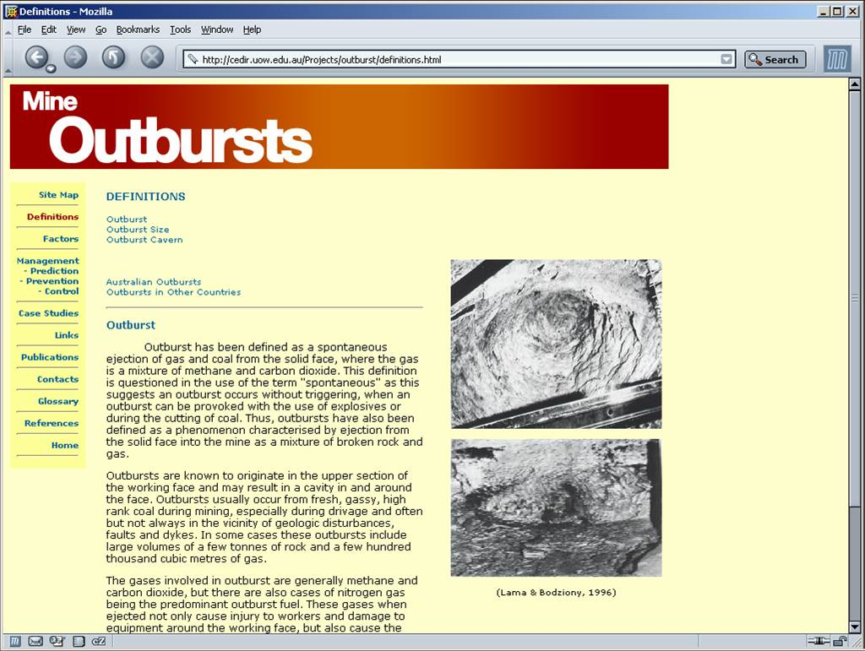

The topics incorporated into this site are:

Sitemap: This module provides an overview of the contents of the website. Links to each and every topic in the website through the site map have been provided, except those areas which are still under construction.
Definition: This module is an introduction to outburst. It defines an outburst and provides links to related topics, Outburst size and Outburst cavern. The definition explains how an outburst occurs, the composition of an outburst and where it occurs. “Outburst Size” assists the user through definition and classification of outburst based on the size.
“Outburst Cavern” defines a cavern and the different types of cavern formed as a result of outburst along with photographs.
Factors: Factors contributing to the occurrence of an outburst is detailed under this section. The various factors are:
Geological conditions:
- Depth of mining
- Faults and folds
- Seam thickness
- Gas environment
- Gas content
- Mining induced stresses

Coal properties:
- Strength of coal seam
- Rank of coal seam
- Coal permeability
- Volumetric change
- Cleats and joints

Management: Mining of seams prone to outburst requires the development of specific procedures to ensure that the risk to miners and equipment is eliminated or reduced. The purpose of the management systems is to ensure that the procedures are in place and are precisely followed to ensure that the mining activities are done as per the management plan. Management of outburst includes:

Prediction:
- Geology
- Prediction indices
- Monitoring
- Geophysical
- Seismic
- Electromagnetic
- Radar
- Radiometric
- Gas environment
- Gas type
- Gas pressure
- Gas content

Prevention:
- Ventilation
- Gas threshold value
- Gas drainage
- Pre-drainage
- Inseam drainage
- Post drainage
- Bore hole survey technique

Control:
- Ground de-stressing
- Gas drainage
- Bore hole survey technique
- Hydro facing
- Pulse infusion shot firing
- Blasting and borehole simulation
- Outburst hazard control
- Outburst management plan

Research and development: This section includes reports of ACARP on the subject as listed under. It include;
- ACARP gas and outburst workshop: 28th August 2004
- Gas and outburst workshop: 22nd November 2003
- Outburst scoping study- John Hanes
- Real time return gas monitoring for outburst and gas drainage assessment.
- Outburst scoping study- March 1996 (Lama & Bodziony)
- Outburst symposium- March 1995

Apart from this, various presentations which relate to the latest developments on mine outburst and the practices being followed at the mine sites at the outburst committee meetings, have also been uploaded and is an ongoing activity. The reports and the presentations can be downloaded from the website.

History: This module presents the historical facts of outburst incidence in Australia and world wide. All efforts are being made to collect information from other countries as well. The Bulli seam outburst in Australia under “National and in Poland under “International” have been uploaded in this section.

Case studies: This section incorporates the case studies of Australian and international mines. Presently uploaded Australian case studies include the Central Colliery outburst, Queensland, which occurred in 2001, and those from Collinsville Colliery, Queensland in 1978, and Leichhardt Colliery, 1975 onwards.

Links: Links have been provided to other relevant national and international mining websites as a source of information on coal and gas outburst and has not been used to actively promote any company, product or alike.
FUTURE ISSUES
The issues to be addressed in the future are:
- Establishing a feed back form
- Chat rooms for two way communication and active discussions
- Uploading information on prediction, prevention and control of outburst
- Modifying the template to be inline with the latest trends.
- International history and case studies to be uploaded.
CONCLUSION
This website through information dissemination will provide:
- Increase awareness of outburst issues- practices and strategies
- Remote access to information
- Public awareness of issues related to outburst, coal mining and green gas effect
- Increase awareness of safety issues – prevention and management
- Availability of information in a timely manner

The website has been placed into the public domain to assist in the upgrading and training of the mining industry personnel as well as raising awareness of the mining operations to the public in general. The website is a valuable source and useful library for those interested bodies in remote regions and rural areas of Australia and also throughout the world. The website will represent a dynamic body of knowledge in this field. Information will be accessible in a virtual environment.
ACKNOWLEDGEMENT
The authors accord their appreciation to ACARP for having funded this project. Various mining companies, mining consultants, government organizations are providing material for the website. Significant material uploaded in the website in power point presentation are compiled and provided by John Hanes. The authors would also like to thank John Hanes and Adrian Hutton of school of geosciences, University of Wollongong, for their assistance with information, pictures and review of some of the material contained in the website. Thanks also extended to Illawarra gas outburst committee for their support.

University of Wollongong

